Class A Public & Private IP Address Range

Class A addresses are for networks with large number of total hosts. Class A allows for 126 networks by using the first octet for the network ID. The first bit in this octet, is always zero. The remaining seven bits in this octet complete the network ID. The 24 bits in the remaining three octets represent the hosts ID and allows for approximately 17 million hosts per network. Class A network number values begin at 1 and end at 127.

* Public IP Range: 1.0.0.0 to 127.0.0.0
  + First octet value range from 1 to 127
* Private IP Range: 10.0.0.0 to 10.255.255.255 (See [Private IP Addresses](https://www.meridianoutpost.com/resources/articles/IP-classes.php#private) below for more information)
* Subnet Mask: 255.0.0.0 (8 bits)
* Number of Networks: 126
* Number of Hosts per Network: 16,777,214

Class B Public & Private IP Address Range

Class B addresses are for medium to large sized networks. Class B allows for 16,384 networks by using the first two octets for the network ID. The first two bits in the first octet are always 1 0. The remaining six bits, together with the second octet, complete the network ID. The 16 bits in the third and fourth octet represent host ID and allows for approximately 65,000 hosts per network. Class B network number values begin at 128 and end at 191.

* Public IP Range: 128.0.0.0 to 191.255.0.0
  + First octet value range from 128 to 191
* Private IP Range: 172.16.0.0 to 172.31.255.255 (See [Private IP Addresses](https://www.meridianoutpost.com/resources/articles/IP-classes.php#private) below for more information)
* Subnet Mask: 255.255.0.0 (16 bits)
* Number of Networks: 16,382
* Number of Hosts per Network: 65,534

Class C Public & Private IP Address Range

Class C addresses are used in small local area networks (LANs). Class C allows for approximately 2 million networks by using the first three octets for the network ID. In a class C IP address, the first three bits of the first octet are always 1 1 0. And the remaining 21 bits of first three octets complete the network ID. The last octet (8 bits) represent the host ID and allows for 254 hosts per network. Class C network number values begins at 192 and end at 223.

* Public IP Range: 192.0.0.0 to 223.255.255.0
  + First octet value range from 192 to 223
* Private IP Range: 192.168.0.0 to 192.168.255.255 (See [Private IP Addresses](https://www.meridianoutpost.com/resources/articles/IP-classes.php#private) below for more information)
* Special IP Range: 127.0.0.1 to 127.255.255.255 (See [Special IP Addresses](https://www.meridianoutpost.com/resources/articles/IP-classes.php#special) below for more information)
* Subnet Mask: 255.255.255.0 (24 bits)
* Number of Networks: 2,097,150
* Number of Hosts per Network: 254

Class D IP Address Range

Class D IP addresses are not allocated to hosts and are used for multicasting. Multicasting allows a single host to send a single stream of data to thousands of hosts across the Internet at the same time. It is often used for audio and video streaming, such as IP-based cable TV networks. Another example is the delivery of real-time stock market data from one source to many brokerage companies.

* Range: 224.0.0.0 to 239.255.255.255
  + First octet value range from 224 to 239
* Number of Networks: N/A
* Number of Hosts per Network: Multicasting

Class E IP Address Class

Class E IP addresses are not allocated to hosts and are not available for general use. These are reserved for research purposes.

* Range: 240.0.0.0 to 255.255.255.255
  + First octet value range from 240 to 255
* Number of Networks: N/A
* Number of Hosts per Network: Research/Reserved/Experimental

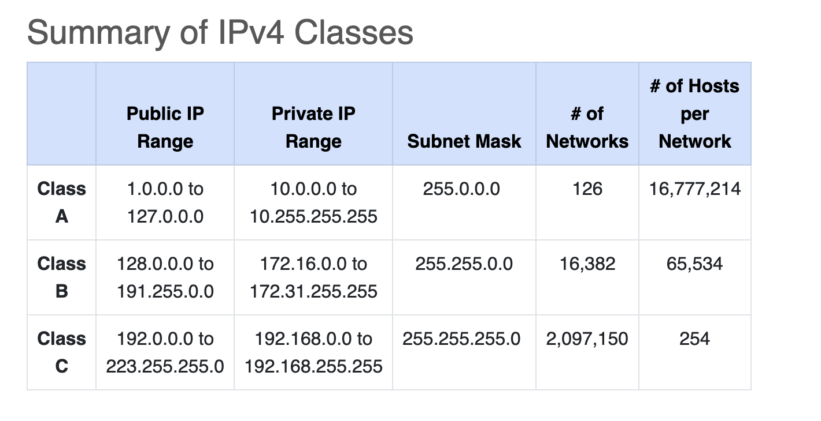

Mark a subnetwork as valid:

* My mental shortcut that works for netmasks >= 25 is I subtract the mask length from 32 and look at the last octet of the IP address... that is the maximum host bits in the address (call that number h). If the last octet is evenly divisible by 2**h, then that is a subnet address.
* For example, 172.16.4.127/26... 32 - 26 = 6. 2**6 = 64 and 127 % 64 = 63. Therefore, 172.16.4.127 is not a valid subnet address... in fact it is the broadcast address for the 172.16.4.64/26 subnet. Good luck with your CCNA exam.
* Do and between ip address and mask, sau or not
* Host range: extract the first and the last one

1. Network Layer Protocols:

• IP (Internet Protocol): This is a fundamental protocol that provides the addressing and routing of data packets across a network. IPv4 and IPv6 are the most widely used versions. •

ICMP (Internet Control Message Protocol): Used for error reporting and diagnostics in IP networks.

1. Transport Layer Protocols:

• TCP (Transmission Control Protocol): Provides reliable, connection-oriented communication. It ensures the ordered and error-checked delivery of data. •

UDP (User Datagram Protocol): A connectionless protocol that provides faster, but less reliable, communication.

**SCTP**: The **Stream Control Transmission Protocol** is a [computer networking](https://en.wikipedia.org/wiki/Computer_networking) [communications protocol](https://en.wikipedia.org/wiki/Communications_protocol) in the [transport layer](https://en.wikipedia.org/wiki/Transport_layer) of the [Internet protocol suite](https://en.wikipedia.org/wiki/Internet_protocol_suite).

1. Application Layer Protocols:

• HTTP (Hypertext Transfer Protocol): Used for transferring hypertext, often used for the World Wide Web. •

FTP (File Transfer Protocol): Used for transferring files between hosts on a network. •

SMTP (Simple Mail Transfer Protocol): Used for sending email between servers. • DNS (Domain Name System): Resolves domain names to IP addresses. •

SSH (Secure Shell): Provides secure, encrypted communication over a network.

1. Data Link Layer Protocols:

• Ethernet: A widely used protocol for local area networks

(LANs) that defines how data is placed on the network. •

PPP (Point-to-Point Protocol): Used to establish a direct connection between two nodes.

A **datagram** is a basic transfer unit associated with a [packet-switched network](https://en.wikipedia.org/wiki/Packet-switched_network). Datagrams are typically structured in [header](https://en.wikipedia.org/wiki/Header_(computing)) and [payload](https://en.wikipedia.org/wiki/Payload_(computing)) sections. Datagrams provide a [connectionless communication](https://en.wikipedia.org/wiki/Connectionless_communication) service across a packet-switched network. The delivery, arrival time, and order of arrival of datagrams need not be guaranteed by the network.

0.0.0.0 – ip-ul pe care il primeste default in host inainte sa ii se atribuie un ip real

TCP IP Reference Model

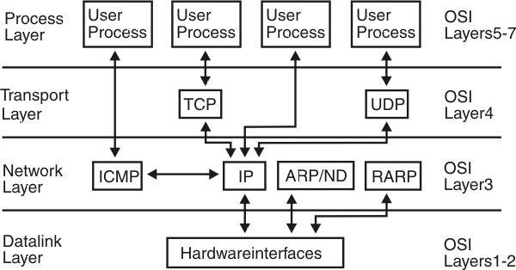

All People Seem To Need Data Processing

Domain + Submain + TopLevelDomain

OSI: Open Systems **Interconnection**Model

